From Bat Bombs to Goo Guns: Crazy Military Experiments
- By Aaron Rowe
- June 9, 2010
Read More http://www.wired.com/dangerroom/2010/06/gallery-crazy-military-experiments/all/1#ixzz0qWoz6OQF
Military researchers have poured blood, sweat, tears and taxpayer dollars into all sorts of wacky experiments. There are plenty of reasons that they are willing to take a take a chance on just about anything. Some may feel that we need to invest in risky projects to keep an edge over our adversaries. Others may view unusual projects as a way of raising money for their own personal crusades.
Above:

Bat Bombs
Toward the end of World War II, the Air Force was looking for a better way to burn Japanese cities to the ground. A dental surgeon contacted the White House, and suggested strapping small incendiary devices to bats, loading them into cages shaped like bombshells and dropping them over a wide area.
According to the plan, millions of bats would escape from the bombshells as they parachuted toward earth, and the flying mammals would find their way into the attics of barns and factories, where they would rest until the charges they were carrying exploded. In the early 1940s, a test with some armed bats went awry, and they set fire to a small Air Force base in Carlsbad, New Mexico.
After that accident, the project was turned over to the Navy, which continued it for more than a year. During that time, the Marines conducted a successful proof of concept at Dugway Proving Grounds in Utah, where they released bats over a mock-up of a Japanese city. The critters were able to start quite a few fires.
Photo: Furryscaly/Flickr
<< previous image | next image >>

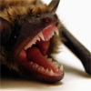 | 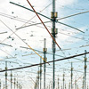 | 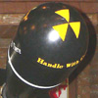 | 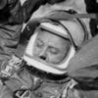 |  | 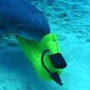 | 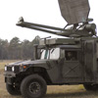 | 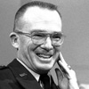 | 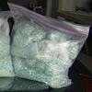 | 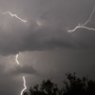 | 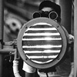

Alaskan Area 51
A few years ago, Todd Pedersen, an Air Force physicist, sat in the snow and watched as auroras — similar to the famous northern lights — began to glow above his base in the Alaska wilderness. But these luminous forms weren’t created by nature. Pedersen had made them himself, with the help of an enormous array of antennas that can hurl several megawatts of radio waves into the upper atmosphere, creating brilliant light shows in the sky.
The facility is known as HAARP, or the High-frequency Active Auroral Research Program, and it is meant to answer some intriguing questions about the ionosphere. But it has raised even more questions among conspiracy theorists. Over the years, it’s been called a weather-control machine, a superweapon and the ultimate underground spying machine. As if creating artificial aurora borealis wasn’t freaky enough.
Photo: João Canziani
<< previous image | next image >>
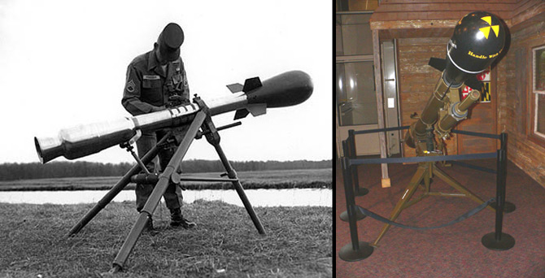

Nuke Test, Too Close for Comfort
When a nuclear warhead detonates, you don’t want to be anywhere nearby. And you definitely don’t want to be taking cover just a couple of miles away. But during the Cold War, a handful of soldiers were ready to start a nuke fight, right up-close and personal, using portable launchers and low-yield bombs.
In the 1960s, the Army had more than two thousand guns meant for launching small nukes, each with a maximum range of only 2.5 miles. The Army lit one of those firecrackers in the Nevada desert during the summer of 1962 while Attorney General Robert F. Kennedy watched. It exploded only 1.7 miles from where it was launched, and was the last above-ground nuclear explosion conducted by the United States.
Photos: U.S. Army (left), Mark Pellegrini (right)
<< previous image | next image >>


Goo Guns
Squirting jihadists with sticky foam may seem like a silly plan, but the Army did explore the option of using goo guns on enemy combatants, if only briefly. Since then, the government has awarded a contract to Adherent Technologies, a materials-research firm. That firm aims to develop an adhesive polymer that could stop vehicles in their tracks, without harming its occupants.
As the nature of warfare changes, favoring urban combat and regional conflicts rather than conventional combat, the military is gaining a great deal of interest in less-lethal weapons. It’s honestly interested in keeping civilian casualties to a minimum, for practical reasons. Every time an innocent gets killed, it stokes the fires of insurgents and looks awful at home.
Many units are equipped with dazzlers, extremely bright laser pointers that can be used in lieu of a warning shot, or as a means of blinding hostiles. And some have the long-range acoustic device, a sound cannon that can be used to issue verbal warnings, or deafen anyone who stands in its path.
Photo: Corbis
<< previous image | next image >>
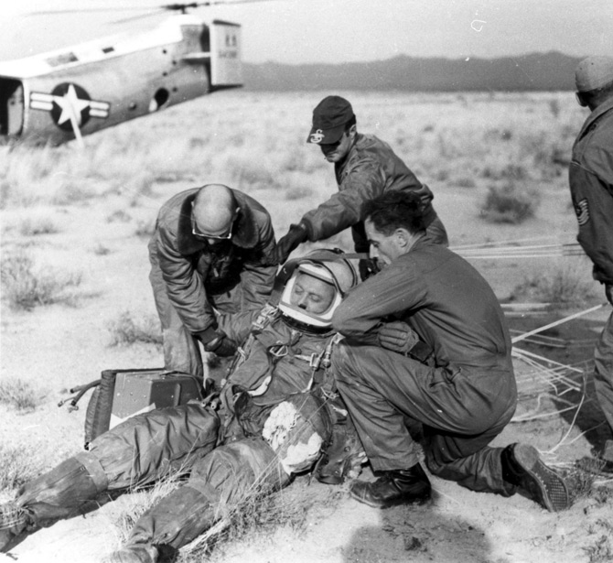

Extreme Skydiving
In 1960, Captain Joe Kittinger rode a balloon up into the stratosphere — 20 miles above the Earth — and then jumped out of it. He hurled toward the ground at 714 miles per hour, faster than the speed of sound, and landed safely in the sands of the New Mexico desert.
His daring leap was part of Project Excelsior, an attempt to explore the safety issues that pilots would face while handling high-flying aircraft. Kittinger’s test proved that an experimental parachute, designed by Francis Beaupre, would hold up under the most extreme conditions.
To date, nobody has broken Kittinger’s altitude record. But a privately funded team, backed by the makers of Red Bull, is trying to do it.
Photo: U.S. Air Force
<< previous image | next image >>
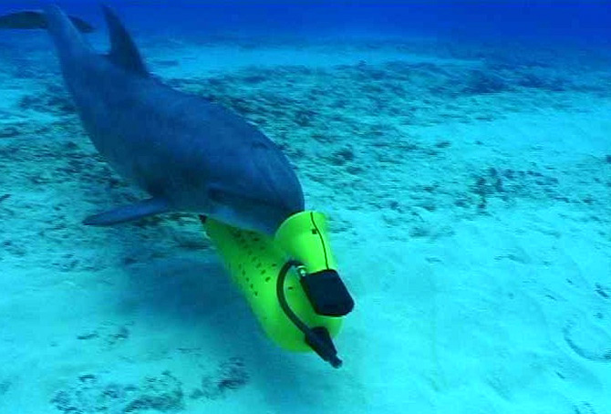

Deadly Dolphins
In the early 1990s, a Russian military officer allegedly trained several dolphins to attack enemy ships. He conducted tests to show that they could recognize different vessels by the sounds of their propellers. In theory, the mammals could be used to drag explosives up to enemy ships, while leaving friendly boats unharmed.
Years later, when he could not afford to care for the animals, he sold them to Iran. Their fate is still unlearned. And rumors persist of even-wilder military dolphin programs — marine mammals taught to kill enemy swimmers.
Photo: U.S. Navy
<< previous image | next image >>
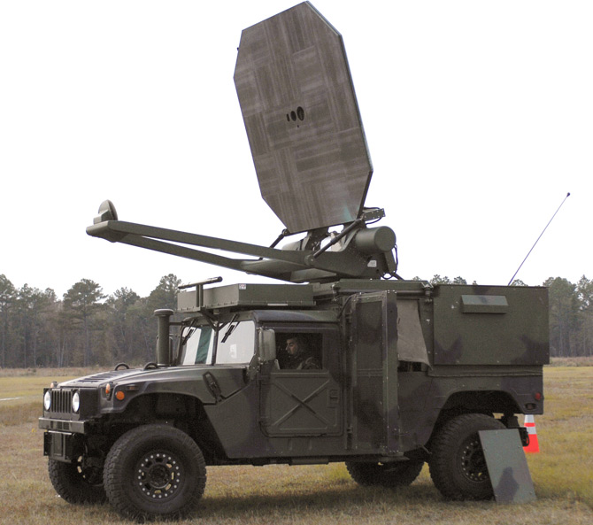

Pain Rays — Not Always That Painful
Tests of the Active Denial System, a ray gun that shoots painful millimeter waves, have ranged from terrifying to laughable. The Air Force released a carefully censored report in 2007, after an airman was burned by an unusually strong beam. He was playing the role of an enemy scout during an exercise that was meant to evaluate the weapon, and got blasted at full power for four seconds.
In a demonstration for reporters (including Danger Room’s own Sharon Weinberger), the people-zapper had the opposite effect. It was raining, and the warmth of the beam was somewhat refreshing.
Credit: U.S. Army
<< previous image | next image >>
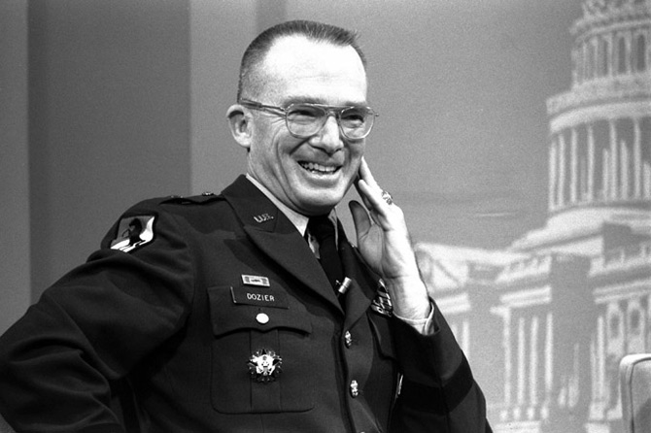

Psychic SWAT Team. Sorta
Terrorists disguised as plumbers kidnapped General James Dozier from his home in Verona, Italy, in 1981 and held him hostage in a secret location. During the first days of the situation, the Italian government would not agree to cooperate with an investigation or rescue effort.
Desperate to find Dozier, the military turned to psychics who were working as part of the Grill Flame program, an experiment in which psychics were rigorously evaluated and then asked to gather reliable intelligence information.
One of the psychics claimed that the general was held in a brick building with a red roof, and another guessed that the hostage was being held in Padua, a small city in the north. Days later, Dozier was rescued by an Italian SWAT team, after a tipster led them to his location.
Dozens of academic scientists, and private contractors, conducted more scientific experiments. Boeing researchers asked volunteers in the 1960s to control a random-number generator with mind powers. Volunteers would attempt to control the outcome with whatever supernatural forces they could bring to bear on the problem.
And according to a document written by the researchers, it worked, sometimes. But not very consistently.
Photo: Gen. James L. Dozier
Bob Daughtery/AP
<< previous image | next image >>
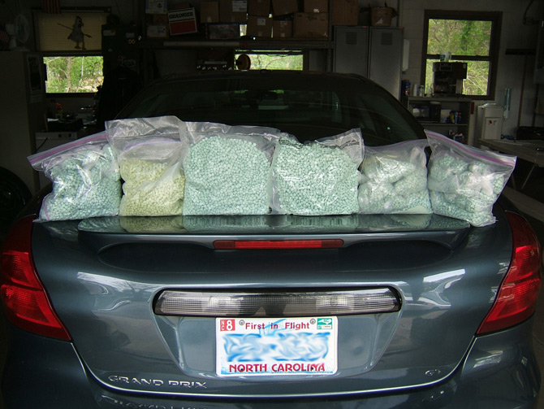

Acid Guinea Pigs
The CIA amassed enough LSD During the Cold War to supply every jam band concert in the world for a dozen generations. An assortment of defense and intelligence agencies tested the acid on soldiers and civilians, and some researchers decided to try it on themselves.
In his memoirs, Army psychiatrist James Ketchum told the story of a colleague who used himself as a guinea pig. The researcher was wandering around in his underwear with a concave piece of glass taped to his arm. Under the glass was a mixture of LSD and ethylene glycol. He wanted to know if the psychedelic formula could penetrate the skin, and nonchalantly said that it wasn’t working.
In another, darker tale, an Army researcher may have been whacked after a botched LSD experiment. While attending an outdoor retreat, Frank Olson sipped a glass of Cointreau, which was laced with LSD, and had an awful reaction. He threatened to resign.
And days later, the biological weapons researcher supposedly hurled himself through the 10th floor window of a New York hotel. CIA representatives said that he had become suddenly depressed. But when his body was exhumed, and examined years later, it seemed that his head had been smashed before the fall.
Photo: Ohio State Highway Patrol
<< previous image | next image >>
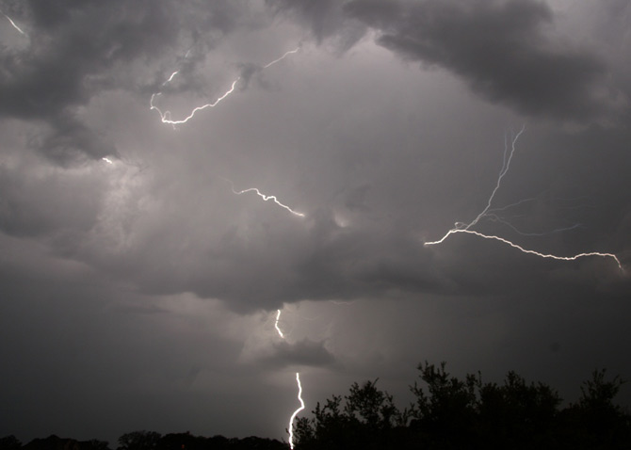

Ride the Lightning
Late last year, Darpa launched lightning cannons that could smite enemy bombs with crackling blasts of electricity. After a series of scandals, the company changed its name to Applied Energetics, and decided to repackage its questionable technology as a means of disabling vehicles or destroying improvised explosive devices.
But the prototypes had a range of only 15 meters, which is too close for comfort when you’re trying to stop a car bomber or detonating mines. Another company, Xtreme Alternative Defense Systems, aims to revolutionize combat with “directed-tuned lightning technology.” That is, when XADS chief Pete Bitar isn’t working on flying cars.
Photo: Longhorndave/Flickr
<< previous image | next image >>
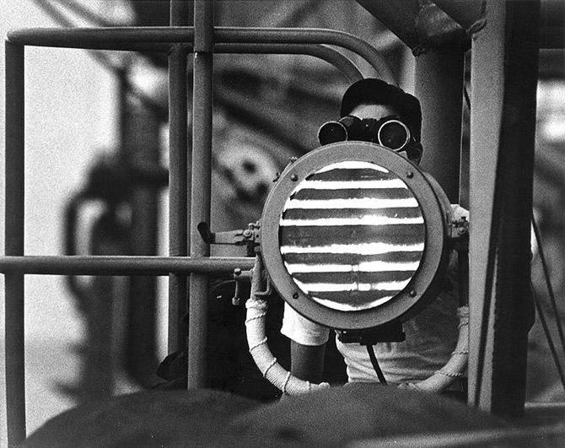

Raccoon Vision
Navy researchers tried to develop a pill that would allow troops to see in the dark, or at least make out flashes of infrared that could be used to send secret messages.
Some animals have pigments in their eyes that allow them to see those wavelengths, which are longer than visible light. But the human retina does not ordinarily produce those molecules.
To give human volunteers raccoon vision, researchers fed them a chemical similar to vitamin A, with the hope that it would turn into the night vision pigment.
Photo: U.S. Navy
See Also:
- Navy Dolphin Patrol Under Fire
- Attack of the Killer Dolphins (Maybe)
- Boeing’s Psychic Lab
- Navy Wants a Few Good Dolphins
- Navy Taps Dolphin Brains for Next-Gen Sonar
- New Site Details Chemical Warfare, LSD Tests
- Inside the Army’s Far-Out Acid Tests
- Army’s Hallucinogenic Weapons Unveiled
- Army’s New PTSD Treatments: Yoga, Reiki, and Bioenergy
- Ecstasy Pushed as PTSD Treatment
- Video: China’s Weather Control Brigade
- Military Science: Hack Stormy Skies to Lord over Lightning
- DARPA Hearts HAARP; Tinfoil Hats Melt
- Navy Research Paper: Disrupt Economies with Man-Made Floods
- Scientist Looks to Weaponize Ball Lightning
- U.S. Readies for Polar Warfare
Read More http://www.wired.com/dangerroom/2010/06/gallery-crazy-military-experiments/all/1#ixzz0qWobwucK

