Nat Rothschild
From the latest news about or mentioning Nat Rothschild to older articles from the MailOnline archive, discover more about Nat Rothschild here...

Peter Mandelson parties with his super-rich chums again ... and the security guards DEFINITELY don't want you to see him
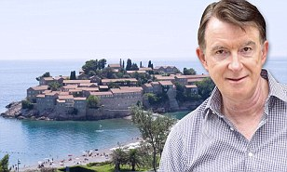
News10/07/2011 18:09
It seems someone was determined the world would not see the Labour peer enjoying the lavish 40th birthday celebrations of his close friend, billionaire Nat Rothschild....read
Keywords

News10/07/2011 16:42

Cameron, Rebekah Brooks and 'the Chipping Norton set': The powerful clique's gilded life
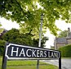
The image of affluent Londoners at play in a picturesque rural setting disguises the true extent of the feuding and power-broking taking place deep in the Oxfordshire countryside.
Keywords

Debate04/07/2011 08:03

PETER MCKAY: Why can't Charles be free to speak out?
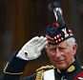
It’s the Prince's duty to keep himself familiar with the workings of government. He has a right to communicate with ministers and prime ministers.
Keywords

News18/06/2011 01:48

Former BP boss Tony Hayward set to pocket share of £410m windfall - a year after catastrophic Gulf of Mexico oil blast that killed 11
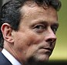
Tony Hayward will make £14million from his latest venture – despite presiding over a disaster that wiped £40billion off the oil firm’s share price.
Keywords

Money17/06/2011 22:17

Vallares, the cash shell backed by Tony Hayward, raises a £1.35bn warchest

Vallares, the cash shell backed by Tony Hayward and financier Nat Rothschild, has raised £1.35bn from investors and is looking to snap up oil and gas assets.
Keywords

Money12/06/2011 22:04

Former BP boss Tony Hayward lines up a Vallares windfall
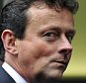
Tony Hayward will share in a £410m windfall if his oil investment firm Vallares proves successful. The vehicle’s co-founders are preparing Vallares for a £1bn listing.
Keywords

Money09/06/2011 21:34

Former BP boss Tony Hayward to float £1bn oil venture
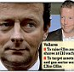
The idea is that owners will receive shares in Vallares so they would get the chance to share in future gains, and Hayward and Rothschild would not have to pay an inflated cash price for their purchases.
Keywords

Money05/05/2011 21:31

MARKET REPORT by GEOFF FOSTER: Rothschild set sights on Footsie

Nat Rothschild, the son of the wealthy banking dynasty, also trousered around £6m when his mining investment firm Vallar (25p cheaper at 1350p) was floated last year.
Keywords

News04/05/2011 13:07

Greed Inc: A special investigation into pollution, dubious tax practices and exploitation of African workers at Glencore
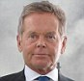
This is the charge sheet against the shadowy firm run by British ex-legionnaire Simon Murray which is poised to become a £30bn giant of the FTSE 100.
Keywords

Money04/05/2011 01:26

Commodities giant set to unveil flotation prospectus
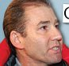
The share offer is likely to be valued at the lower end of expectations but is still expected to make dollar billionaires of chief executive Ivan Glasenberg and three top trader colleagues.
Keywords

Money25/04/2011 22:07

CITY COMMENT: Sexism is not the worst problem for Glencore

Chairman Simon Murray’s views on women may be questionable, but his assertion that Glencore has no questions to answer on corporate governance defies credence.
Keywords

News02/04/2011 00:59

I'm Mandy - buy me: Revealed, the shameless letter that Mandelson is using to tout for business from despots and dodgy billionaires
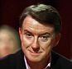
The word 'genius' doesn’t actually appear in the letter he has despatched promoting his new consultancy, Global Counsel. But he comes breathtakingly close.
Keywords

News18/03/2011 00:00

Will Ireland return to Royal fold?
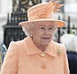
On the eve of one of the most historic royal visits of modern times, I have news of an intriguing diplomatic mission. For exactly 100 years after a British monarch last stepped foot on Irish soil, there is the prospect of the Emerald Isle rejoining the Queen’s most cherished institution, the Commonwealth.
Keywords

News17/03/2011 03:31

How Andrew's night in Balkans cost taxpayer £10,000 (... after he turned down an £86 room in five star hotel)
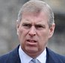
Brad Pitt, Madonna, the Rolling Stones and 34 heads of state have all enjoyed their stay. But it seems the five-star Hotel Splendid on Montenegro’s Adriatic coast was not quite splendid enough for the Prince.
Keywords

News02/03/2011 23:40

Lord Mandelson should be investigated over alleged links to Gaddafi regime, says Prime Minister
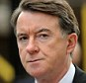
David Cameron was today responding to reports that along with other high-profile political figures Labour's former business secretary has worked with Gaddafi's regime.
Keywords

News28/02/2011 19:08

EU agrees to impose sanctions on Libya as world leaders crank up the effort to remove Gaddafi
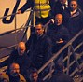
The Prime Minister, Tony Blair and Hillary Clinton all stepped up the international pressure on the defiant Libyan leader with harsh warnings and tough new sanctions.
Keywords

News28/02/2011 17:27

Shameless Mandelson defends Gaddafi's clan as he claims Blair was 'absolutely right' to make friends
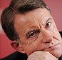
The former cabinet minister even said Saif, the second son of Colonel Gaddafi, should have called him for advice on spinning a positive message ahead of television address.
Keywords

Debate24/02/2011 09:06

STEPHEN GLOVER: Shabby politics and the appeasing of a monster
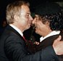
With Col Muammar Gaddafi’s troops turning their guns on their own people, reportedly causing hundreds of fatalities, it is clear that the Libyan dictator is nastier and more ruthless than any other Arab despot in the region. That is saying something.
Keywords

Debate24/02/2011 09:01

EPHRAIM HARDCASTLE: Oddball banker's friendship with Gaddafi's son is remarkable
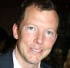
Colonel Gaddafi confiscated all Jewish property in Libya when he came to power. All debts to Jews were cancelled and emigration legally prohibited.
Keywords

News24/02/2011 00:31

Gaddafi 'personally gave the order for Lockerbie bombing' and I have PROOF, claims dictator's former justice minister
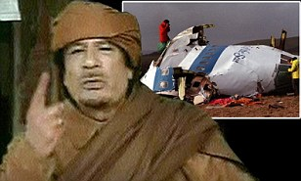
News24/02/2011 00:31
Mustafa Abdel-Jalil, who has just resigned from his cabinet post, told a Swedish newspaper: 'I have proof that Gaddafi gave the order about Lockerbie.'...read
- Comments
Keywords

News22/02/2011 00:27

Gaddafi heir who (inevitably) is a friend of Andy and Mandy
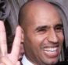
Colonel Gaddafi's son Saif, long seen as the dictator's most likely heir and who warned opponents of 'rivers of blood',has friends in the British establishment including Prince Andrew and Peter Mandelson
- Comments
Keywords

News22/02/2011 10:33

Hypocrisy goes on: Cameron takes arms dealers with him on Egypt visit to promote democracy
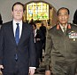
Mr Cameron yesterday became the first world leader to visit Egypt since the historic overthrow of President Mubarak.
- Comments
Keywords

News08/02/2011 21:54

QUENTIN LETTS: Is there any bigger hypocrite than Peter Mandelson?
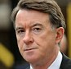
When Peter Mandelson was majordomo in Gordon Brown’s Government, he clawed into Barclays' ‘Bonus Bob’ Diamond. But that was then and now is now.
- Comments
Keywords

News19/01/2011 01:59

Moneybags Mandelson lines up top job at investment bank
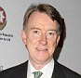
The former Business Secretary has already been raking in the cash since Labour was ousted, but he is apparently now in talks with Lazard, although how much he will be paid is unknown.
- Comments
Keywords

News05/01/2011 15:16

Wills plays Cupid for pal Pelly
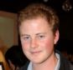
Prince William is hoping to play Cupid in order to save the romance of royal favourite Guy Pelly.
- Comments
Keywords

Debate31/12/2010 09:56

RICHARD KAY: New Year and Maggie is home alone

As the nation prepares to dance into the wee small hours to celebrate the New Year, spare a thought for the woman acclaimed as Britain’s greatest post-war Prime Minister, Baroness Thatcher.
- Comments
Keywords

News31/12/2010 00:06

Arch-networker Mandy banned from lobbying: No Blair-style cashing in for next two years, say MPs
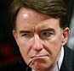
The former Labour minister has been told he must not attempt to influence decision-makers in Whitehall on behalf of foreign billionaires and wealthy corporations.
- Comments
Keywords

Money18/11/2010 21:07

South African activist Julian Treger hits jackpot with stake sale
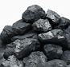
The South African activist's Audley European Opportunities fund has sold a 23.5pc stake in AIM-listed Western Coal to Walter Energy, a $5bn American coal producer, in a $3.25bn cash-and-shares deal.
- Comments
Keywords

News29/09/2010 00:00

Prince in £1bn battle bares all

Any day now, the final act in a bitter battle between two adopted siblings and a £1billion legacy of treasures is being eagerly anticipated in the gossipy and back-stabbing arts world.
- Comments
Keywords

Debate11/09/2010 22:04

PETRONELLA WYATT: The police? They drive me barking mad!

In case you didn't know, we have a Black Police Association, a Gay Police Association, a Muslim Police Association, and, as I found out last week, an Arresting Dogs For Barking Association.
- Comments
Keywords

News10/07/2010 11:47

From the Prince of Darkness, a tale with a sting: Mandelson stars in TV advert for his autobiography
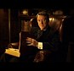
Seated in a leather chair in an oak panelled office, Lord Mandelson said: 'Are you sitting comfortably? Then I'll begin.
- Comments
Keywords

Money30/06/2010 17:15

Rothschild's latest firm to sail onto the market

Playboy financier Nat Rothschild is aiming to raise £600m by floating an investment company called Vallar that wants to be the next Xstrata.
- Comments
Keywords

News28/05/2010 00:00

Dukes at war over 400ft wind turbines
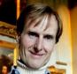
Between them they have inherited an aristocratic lineage of two historic dukedoms, own several vast estates encompassing some of the most beautiful landscapes in Britain — not to mention two of the country’s best-known castles. By any standard, they should be natural allies.
- Comments
Keywords

News26/05/2010 09:31

Mandelson driven around Alps in classic Ferrari of Rothschild heir at the centre of £500m dinner with an oligarch

The former Business Secretary is pictured in the passenger seat of a Ferrari Daytona Spider. At the wheel is his friend, 38-year-old banking heir Nat Rothschild.
- Comments
Keywords

News22/05/2010 10:50

SPECIAL INVESTIGATION: Mandelson, an oligarch and a £500m deal over dinner that cost hundreds of UK jobs
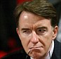
The former Business Secretary was a 'valuable extra' as a dinner guest as billionaire Oleg Deripaska entertained American aluminium executives in Moscow, the Daily Mail can reveal.
- Comments
Keywords

News14/02/2010 09:53

Alexander McQueen's ex-partner throws a disturbing light on the 'hangers-on' who lionised him, but who never truly knew him
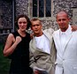
From the outside, the world in which the fashion designer existed appeared glittering and dazzling. Yet the word which recurs as George Forsyth tries to make sense of his suicide actions is 'lonely'.
- Comments
Keywords

News09/01/2010 03:07

New twist in Mandy's Westminster power game... his godson is helping David Miliband mount leadership challenge
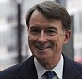
Joe Carberry's appointment has already become the matter of feverish gossip among party kremlinologists who say it is yet more proof that Mandelson likes to have friends in every important place.
- Comments
Keywords

Money30/12/2009 01:10

Oligarch eyes Hong Kong for Rusal flotation

Controversial Russian oligarch Oleg Deripaska is set to float his aluminium group Rusal in Hong Kong next month with a little help from his friend Nat Rothschild.
- Comments
Keywords

Debate22/12/2009 13:14

DAILY MAIL COMMENT: Labour's plutocrats
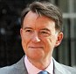
Lord Mandelson increasingly behaves as if the British Government merely exists to satisfy his whims.
From the latest news about or mentioning Nat Rothschild to older articles from the MailOnline archive, discover more about Nat Rothschild here...

Big cheese banker Nat goes Swiss
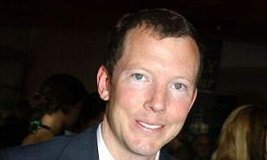
Debate21/10/2009 16:06
Worried that Gordon Brown may further tighten the screws on the beleaguered British taxpayer, astute highflier Nat Rothschild, whose family count their fortune in billions, has decided to fly the fiscal coop...read
- Comments
Keywords

News21/10/2009 15:35

So why did the black sheep of the Rothschilds stab his friend in the back?
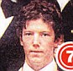
One thing friends have learned to expect from Nat Rothschild is the unexpected.
- Comments
Keywords

News03/10/2009 09:46

George Osborne: Why I'm ready to be Mr Nasty

Mr Osborne could soon be grappling with Britain's biggest ever debt. He reveals candidly he's warned his eight-year-old son: 'Daddy's going to be unpopular'
- Comments
Keywords

Debate02/09/2009 14:00

STEPHEN GLOVER: The release of Megrahi is a vintage Labour scandal
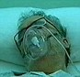
It involved Tony Blair, Jack Straw, Gordon Brown, who knew what was going on, and did not stop it; and Peter Mandelson, who shamelessly denied the whole thing.
- Comments
Keywords

Debate01/09/2009 02:10

RICHARD KAY: Why Duchy boss faced the crunch

Chief executive Andrew Baker, 49, has been banned from being a company director in Nigeria.
- Comments
Keywords

News24/08/2009 20:43

MacAskill tells Scottish MPs Libya broke its promise to make return of the Lockerbie bomber 'low-key'

Scotland's Justice Secretary has accused Libya of breaking assurances that the Lockerbie bomber's return would be dealt with 'in a low-key and sensitive fashion'.
- Comments
Keywords

Debate24/08/2009 15:29

RICHARD PENDLEBURY: The despot's son, a Corfu soiree and yet more questions for the Fixer Supreme

Mutual connections, 'chance' meetings and social back channels are often what make the diplomatic and economic worlds go round. But Lord Mandelson's Adriatic vacations?
- Comments
Keywords

News24/08/2009 01:47

Libya: After Lockerbie bomber's release the heat's on Mandy as he's forced to deny deal with Gaddafi
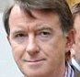
Lord Mandelson faced fresh questions last night over his friendship with businessmen close to Colonel Gaddafi's son - who escorted the Lockerbie bomber home.
- Comments
Keywords

Debate18/08/2009 22:19

RICHARD LITTLEJOHN: Screaming Lord Mandy's nauseating flying circus
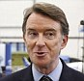
The most odious man in politics has been transformed into Westminster's answer to Stephen Fry. The boys in the bubble hang on his every word.
- Comments
Keywords

News18/08/2009 08:26

Mandy met Gadaffi's son on holiday, days before freedom decision for Lockerbie bomber. ANOTHER 'coincidence' in Corfu?

Lord Mandelson faces the prospect of a sleaze investigation after he met Colonel Gaddafi's son days before it emerged that the Lockerbie bomber was to be freed.
- Comments
Keywords

Debate13/08/2009 01:30

Is Michael Seed in the cardinal sin-bin for his pray-and-tell memoirs?

Now, just weeks after the publication of his autobiography, Sinners And Saints, celebrity priest Fr Michael Seed is facing the potential wrath of another high falutin' acquaintance, namely His Holiness Pope Benedict XVI.
- Comments
Keywords

News12/08/2009 16:36

Mandelson accuses Osborne of political 'cross-dressing' over Tory's public service relaunch
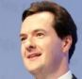
Lord Mandelson last night reignited his bitter feud with George Osborne by accusing the Shadow Chancellor of being a ' political cross-dresser'.
- Comments
Keywords

News14/03/2009 11:24

GEOFFREY LEVY: Why has Prince Andrew been cosying up to dubious oligarchs?
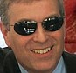
Does the Duke of York's new circle of rich, foreign friends pose a potential risk to the reputation and integrity of the Royal Family?
- Comments
Keywords

News10/03/2009 01:56

Drug raid ordeal for Tara Palmer-Tomkinson

Even for the most seasoned traveller, it would be unnerving. For former It-girl Tara Palmer-Tomkinson it was all the more surprising given her pampered entrance by private jet.
- Comments
Keywords

News28/02/2009 01:34

Peter Mandelson's friends: How the twice disgraced peer is once again at the centre of a tangled web of intrigue
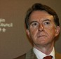
As New Labour guru Peter Mandelson's close ties to Roland Rudd are revealed, an impressive nexus of power and money not only remains intact but has flourished.
- Comments
Keywords

News13/11/2008 08:43

The Prince of Angst: Troubled Charles turns 60 fearing the public hasn't accepted Camilla... and worrying if he'll ever be king
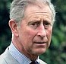
Tomorrow, Charles celebrates his 60th birthday. But he does so as a deeply troubled man, tortured by the public's refusal to accept Camilla and doubts over whether he will be King.
- Comments
Keywords

News31/10/2008 00:07

TOM UTLEY: I know the Lord says turn the other cheek, but give me an eye for an eye any time!
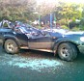
I can't help feeling a grudging sympathy with the Indian call-centre operator who acted vengefully to change the bank details of carpenter George Bates.
- Comments
Keywords

News29/10/2008 11:57

Shotguns at dawn: Osborne and Rothschild in the days before they had each other in their sights
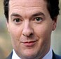
They may have been armed but the fresh-faced members of the Bullingdon Club definitely weren't dangerous.
- Comments
Keywords

News29/10/2008 11:37

Veteran KGB spy revealed as right-hand man to Mandelson's oligarch friend
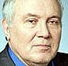
A former KGB spymaster who dealt the British secret service its worst blow since the Cold War is right-hand man to Lord Mandelson's controversial Russian friend Oleg Deripaska, it was revealed today.
- Comments
Keywords

News28/10/2008 00:46

RICHARD KAY: Lady Jane springs a surprise

As the well-brought-up daughter of the nonagenarian Duke of Wellington, Lady Jane Wellesley is naturally fulsome in the acknowledgements for her weighty new history of her aristocratic clan, A Journey Through My Family.
From the latest news about or mentioning Nat Rothschild to older articles from the MailOnline archive, discover more about Nat Rothschild here...

Mystery of the two missing hellraisers: George Osborne and the spirits at the drinking party
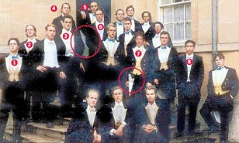
News27/10/2008 14:31
Two ghostly figures appear to be lurking alongside the future Shadow Chancellor and his fellow members of the hellraising Bullingdon Club....read
- Comments
Keywords

News27/10/2008 08:28

Brown denies Mandelson 'did a final favour for Russian oligarch Deripaska'
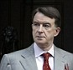
Gordon Brown has brushed aside new allegations about Lord Mandelson's links to Russia's richest man. The Prime Minister said all of his Business Secretary's dealings with Oleg Deripaska had been 'above board'.
- Comments
Keywords

News27/10/2008 00:00

High living of Osborne the younger
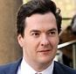
While a chastened George Osborne promises never again to solicit money from wealthy men for the Tory Party, I hear the Shadow Chancellor is not the only family member to enjoy the hospitality of billionaires.
- Comments
Keywords

News26/10/2008 18:14

Did Deripaska use his power at the Kremlin to get Mandelson past immigration without the right papers?
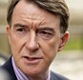
Peter Mandelson is at the centre of a fresh mystery over claims that the owner of the luxury yacht he stayed on used his influence in the Kremlin to get him into Russia without the documents needed to enter the country.
- Comments
Keywords

News26/10/2008 01:37

New row after claims multi-millionaire Nat Rothschild was 'behind George Osborne's £200,000 gift'
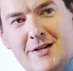
Shadow Chancellor George Osborne was embroiled in a new row last night over claims that multi-millionaire playboy and financier Nat Rothschild was responsible for bankrolling him with nearly £200,000 of funding.
- Comments
Keywords

News26/10/2008 01:37

Use my Ferrari, Mandelson is told by Nat Rothschild while on summer Klosters holiday
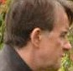
Nat Rothschild urged Lord Mandelson and his friends to use his expensive fleet of cars, including a Porsche and a Ferrari, during a stay at his luxury Swiss chalet in August.
- Comments
Keywords

News26/10/2008 00:29

'I'll be more careful about who my friends are' writes Mandelson as he admits he knew oligarch for years
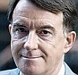
Lord Mandelson has sensationally confirmed that his links to the Russian oligarch at the centre of the 'Yachtgate' affair stretch back years further than he had admitted.
- Comments
Keywords

News25/10/2008 23:04

Nat Rothschild is 'a very naughty boy', says former mother-in-law
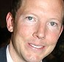
The mother of the woman the playboy multi-millionaire married for two years explains why she will have nothing to do with him now.
- Comments
Keywords

News25/10/2008 22:50

PETER HITCHENS: Not even Kim Jong II could live down a visit from Mandy
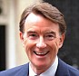
So here we see our new, one-party elite in all its lack of glory, interchangeable careerists from fake ‘Tory’ and fake ‘Labour’ front benches, floating around in lukewarm seas of money with Russian oligarchs and who knows what else?
- Comments
Keywords

News24/10/2008 18:53

George Osborne loses support of voters as poll finds just one in six back his ability
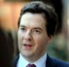
Just one in six voters believe George Osborne is fit for high office, a new poll has suggested in the wake of the 'yachtgate' scandal.
- Comments
Keywords

News24/10/2008 16:21

Was this why Osborne was knifed? Now Mandelson faces questions over his own links to Russian tycoon
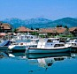
Peter Mandelson has been dragged back into the political storm swirling around his controversial links with Russia's richest man.
- Comments
Keywords

News24/10/2008 01:00

The Mafia paradise that holds secret to tycoons' alliance
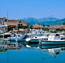
Springtime in Brussels and a familiar figure is wreathed in smiles as he announces his latest diplomatic masterstroke.
- Comments
Keywords

News23/10/2008 20:48

Sequel to a modern love Tory
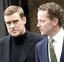
He remains a close confidant of Tory leader David Cameron, but these are bittersweet times for Conservative MP Greg Barker.
- Comments
Keywords

News23/10/2008 19:20

Fresh calls for probe into claims George Osborne sought illegal donation from Russian billionaire
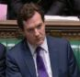
Fresh calls have been made for an inquiry into claims that shadow chancellor George Osborne sought an illegal donation from a Russian billionaire.
- Comments
Keywords

News23/10/2008 15:05

Osborne 'criticised David Davis' during Corfu meeting with Mandelson
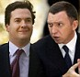
George Osborne faced fresh embarrassment today after it was reported he had privately criticised David Davis in a conversation with Peter Mandelson.
- Comments
Keywords

News23/10/2008 13:55

Tories face questions over £6,000 donation from the City's 'golden girl'

The Conservatives faced fresh claims today that they took money from a well-known U.S. woman, dubbed the 'City's golden girl, via her British investment company.
- Comments
Keywords

News23/10/2008 01:27

STEPHEN GLOVER: While the BBC's knives are out for Osborne, Mandy is getting away with murder
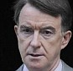
George Osborne has been a fool. Maybe worse than a fool. He met the controversial Russian billionaire Oleg Deripaska five times in the space of a few days. By his own admission he discussed a donation.
- Comments
Keywords

News22/10/2008 00:42

Plotting and poison in a billionaire's playground

An ugly war of words has been sparked between former Oxford buddies, financier Nat Rothschild and George Osborne, creating suspicions of political revenge and, sadly, the shadow of sleaze once again stalking the Tory Party.
- Comments
Keywords

News22/10/2008 00:16

Mandy tycoon's rival hides in Britain in new twist to Russian donor scandal
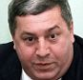
A tycoon who clashed with Lord Mandelson's billionaire friend Oleg Deripaska has sought sanctuary in Britain. The Home Office, advised by the security services, decided that businessman Mikhail Gutseriev would be at risk if he was made to return home to Russia.
- Comments
Keywords

News22/10/2008 01:42

Osborne fights for survival as Rothschild defends bombshell letter that put Tory in hot water
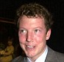
George Osborne faced a new accusation tonight that he took a personal interest in how the Tories could obtain a donation from a Russian billionaire.
From the latest news about or mentioning Nat Rothschild to older articles from the MailOnline archive, discover more about Nat Rothschild here...

Mandy, more generous hospitality from tycoons and fresh questions about the minister's judgment
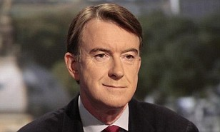
News20/10/2008 01:14
Peter Mandelson has been forced to defend himself after fresh disclosures about his links to rich businessmen....read
- Comments
Keywords

News16/10/2008 23:42

MAIL COMMENT: Whiff of sleaze still follows Mandelson
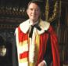
Two weeks ago, when Gordon Brown returned his arch-enemy Peter Mandelson to the Cabinet for the second time, the Mail warned it was a huge political gamble.
- Comments
Keywords

News15/10/2008 09:53

Tories demand answers over Lord Mandy's links with super-rich Russian oligarch
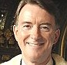
Peter Mandelson was at the centre of disturbing new questions last night over his relationship with one of the world's richest men.
- Comments
Keywords

Debate24/04/2007 21:16

High seas adventure for Fergie

She doesnt have good sea legs and the 17-deck liner is hardly going to be helpful for her claustrophobia.
- Comments
Keywords

News07/04/2007 10:56

Oxford 1992: Portrait of a 'classless' Tory
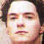
The Tories' attempt to build a classless image has hit another obstacle as Shadow Chancellor George Osborne, like his leader David Cameron, was 'outed' as a member of the hellraising Bullingdon club at Oxford University
- Comments
Keywords

Debate17/10/2006 13:06

Writer's dog helps out a cat burglar
Best-selling novelist Una-Mary Parker has become the latest celebrity victim of that scourge of the fashionable classes: the cat burglar.

